UBook Guide
Contents
Logging in 2
How to access UBook 2
How to log in 2
Checking the diary 3
Room Information 5
LE&D Hub 5
Undercroft 5
Lecture Theatre 5
New Alderley House Boardroom and Meeting Rooms 5
Making a booking request 6
If you know which room you want 6
If you don’t know which room you want 8
Recurring bookings 10
Approval and confirmation 11
Viewing or cancelling bookings 11
Rejected bookings 13

Logging in

How to access UBook
From the ConnECT homepage, hover the mouse over the ‘Support Services’ tab and click ‘UBook – Room Bookings’ to open UBook.
You can also open it at this link: https://UBook.eastcheshire.nhs.uk/
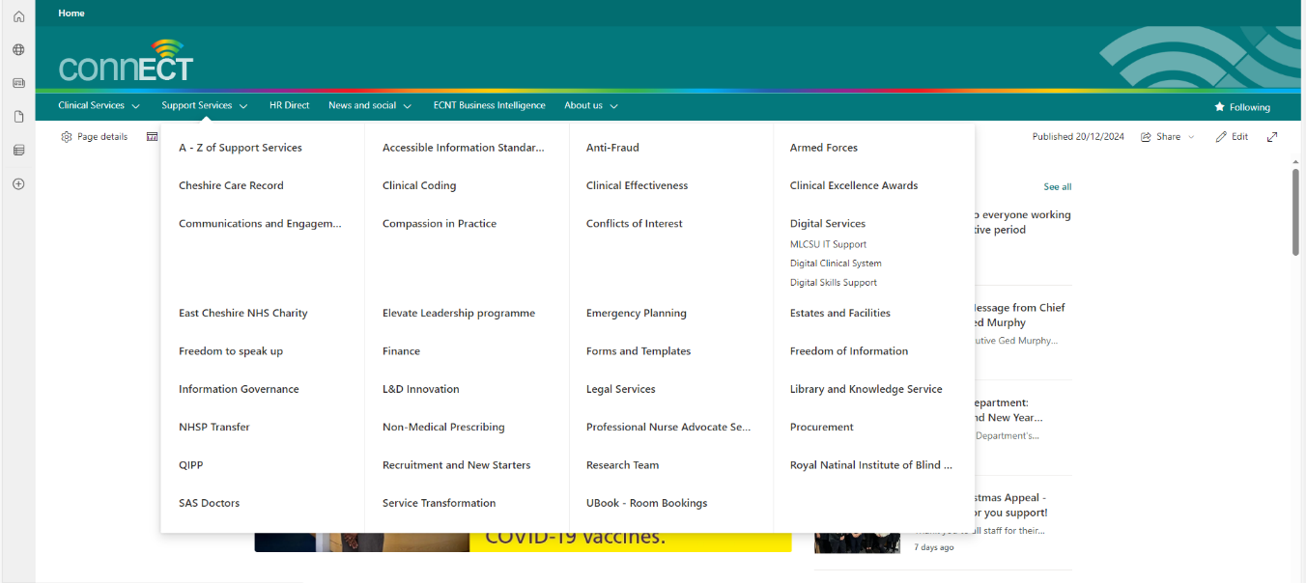
For more information about room bookings, scroll down on the ConnECT homepage and click ‘Room Bookings’. You can also access this at this link: Room Bookings.
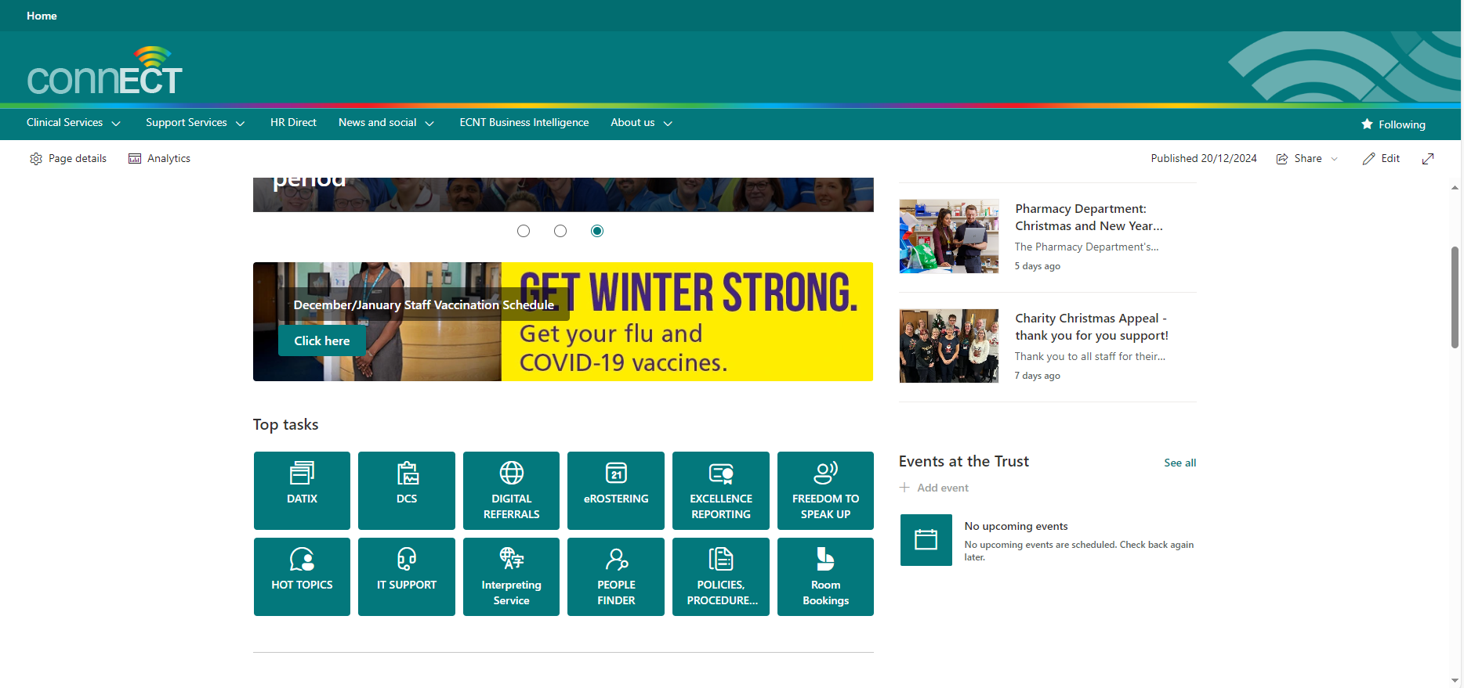
The Room Bookings page has information about the different rooms available.

How to log in
When you open UBook, you’ll be taken to the NHSMail login screen.
Enter your East Cheshire NHS email address and password and click ‘sign in’.
You will then be prompted by multi-factor authentication (MFA) depending on what method you have set up. For information on setting up MFA, click here.
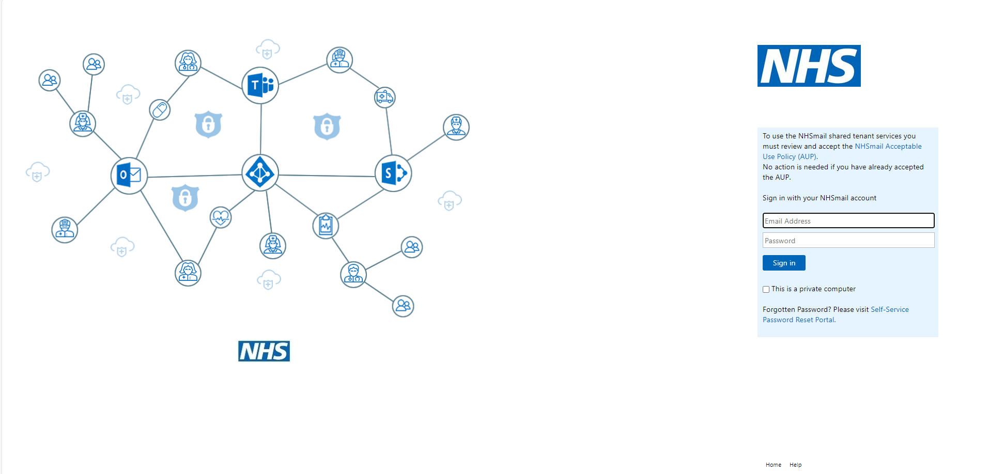
Once you’ve signed in, you’ll be taken to the UBook homepage.
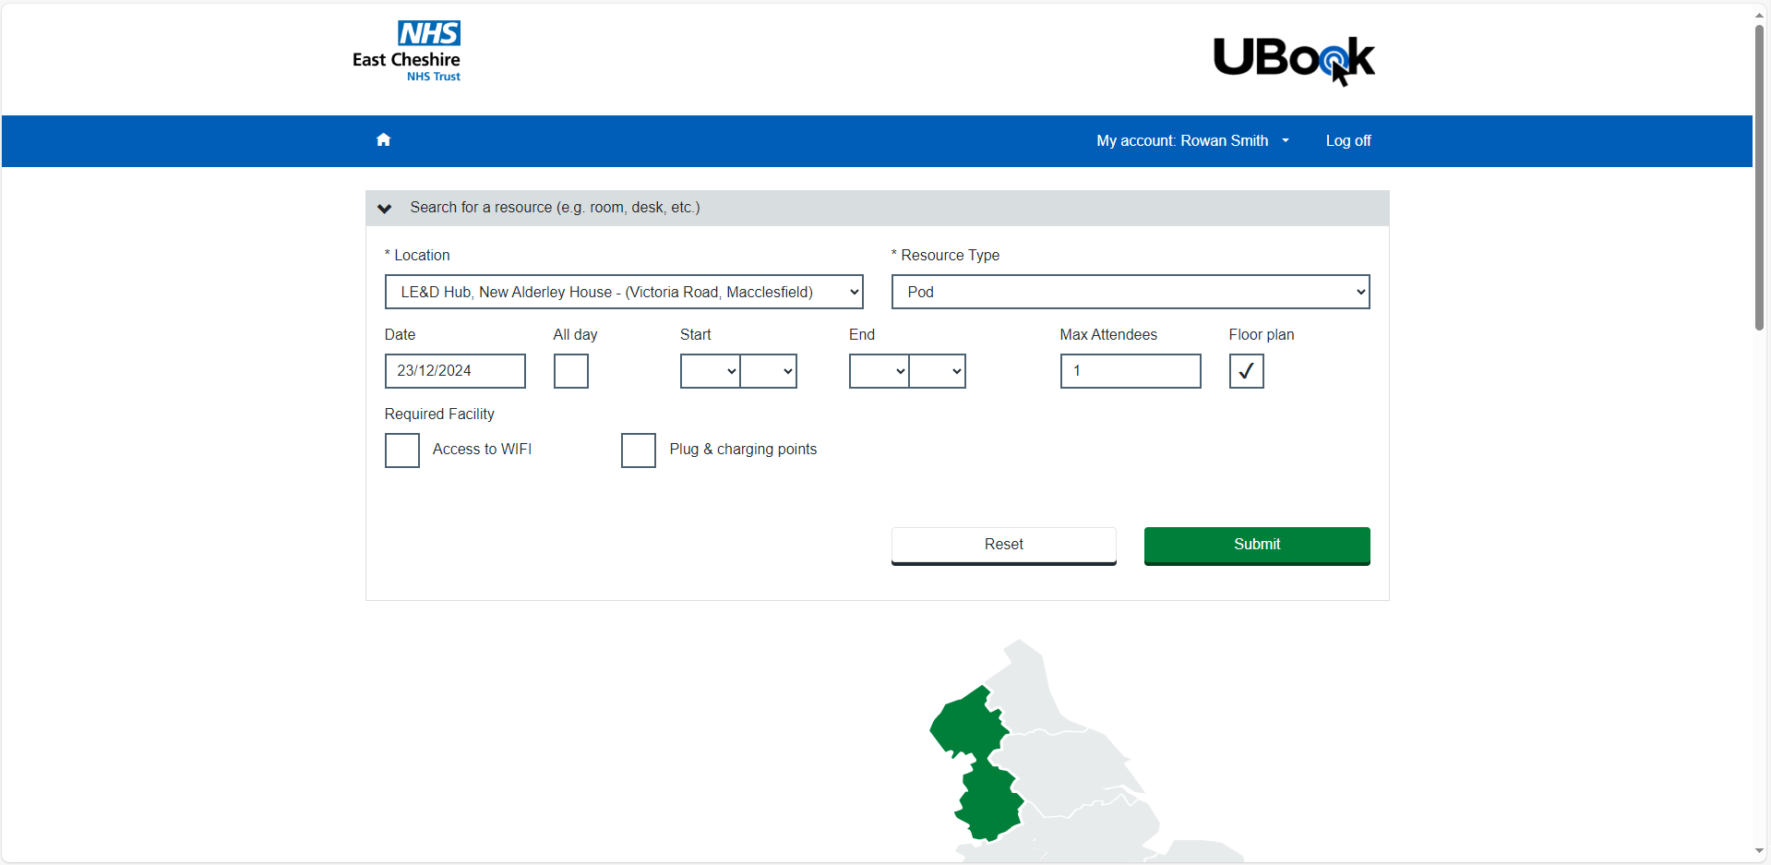

Checking the diary
From the UBook homepage, scroll down to view the diary. It’s best to check the diary before making any bookings.
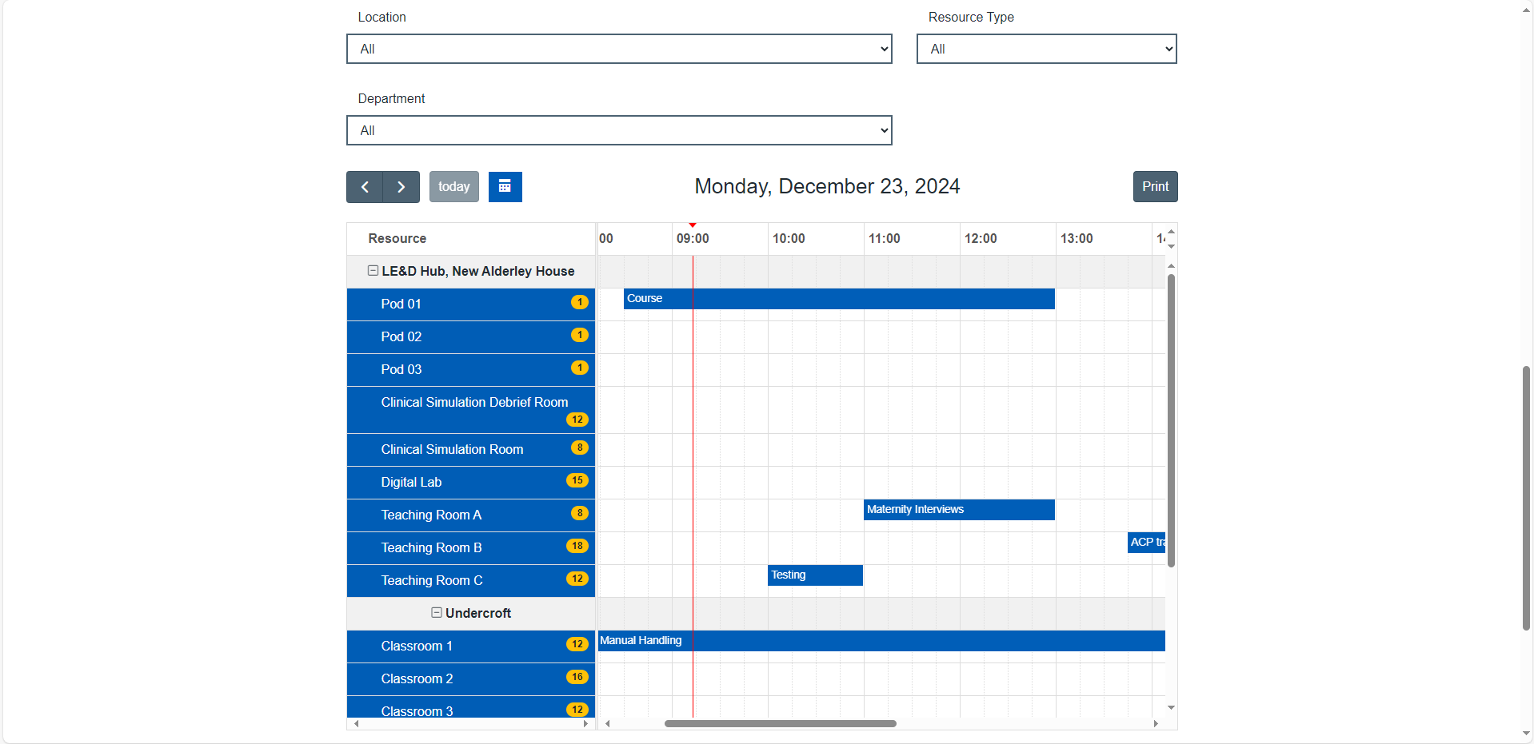
Change the location to ‘All’.
Use the scroll bar on the right of the diary to view all the rooms.
Use the scroll bar at the bottom of the diary to view different times.
The room capacity is shown by the numbers in the yellow circles next to the room name.

The date will show at the top of the diary. Click the calendar icon and select the date you want.
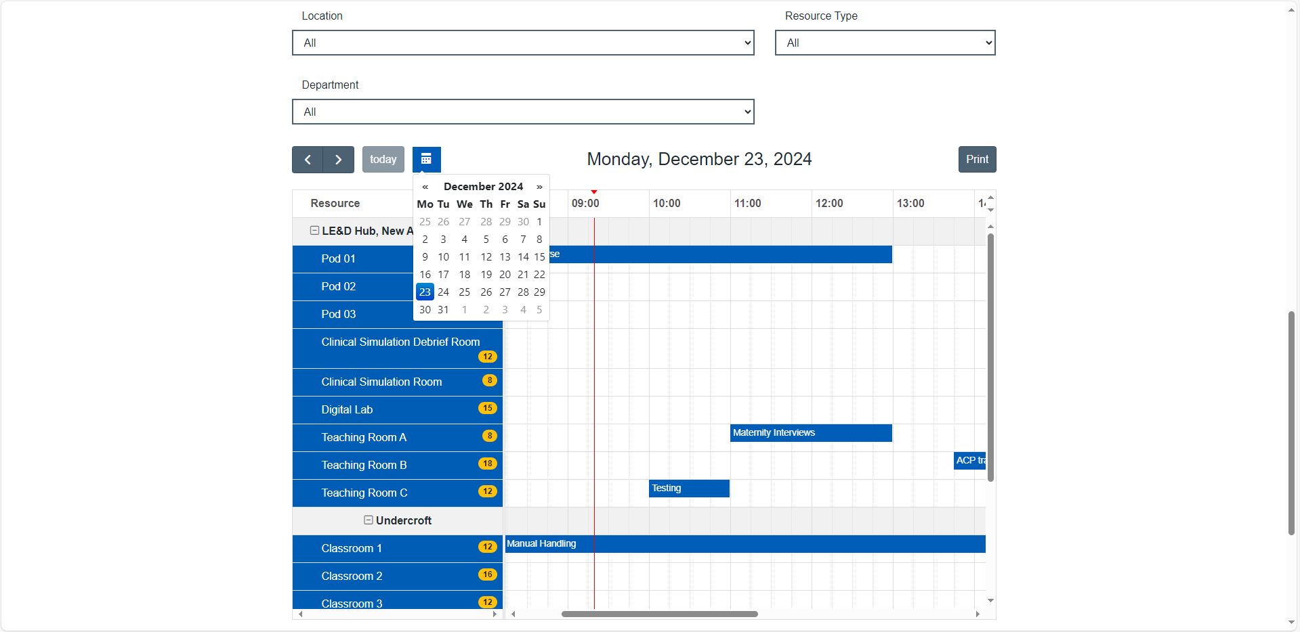
Existing bookings are shown in blue.

Room Information

LE&D Hub
The LE&D Hub, New Alderley House, can be used to book education and training. It has the following rooms:
- Pods – capacity of 1. Use for individual study or taking calls.
- Teaching Room A - capacity of 8. PC and interactive screen.
- Teaching Room B - capacity of 18. PC and projector.
- Teaching Room C - capacity of 12. PC and interactive screen.
- Teaching Rooms B and C can be booked together and opened out into one large room. Capacity of 30.
- Digital Lab - 15 networked PCs. PC and interactive screen for presenting.
- Simulation suite
- Simulation Debrief Room - capacity of 12. Screen but no PC. Please bring a laptop if required.
For queries, email ecn-tr.leadhubrooms@nhs.net.

Undercroft
While you can view the Undercroft rooms, you can’t book these through UBook. Contact the Professional Practice Team on ecn-tr.professionalpracticeteam@nhs.net.

Lecture Theatre
The Lecture Theatre has a capacity of 60 and contains a PC and screen with projector. For queries, email ecn-tr.leadhubrooms@nhs.net.

New Alderley House Boardroom and Meeting Rooms
New Alderley House also has the following rooms:
- Boardroom (2nd floor) - has a capacity of 16 with two screens (camera and microphones built in), a built-in PC and a connection for a laptop if required.
- New Alderley Meeting Room 1 (1st floor) - has a capacity of 8 with a screen connected to a laptop.
- New Alderley Meeting Room 2 (1st floor) - has a capacity of 8 with a screen and connection for a laptop (please bring your own laptop).
For queries, email ecn-tr.meetingroombookings@nhs.net.

Making a booking request
There are two ways to make a booking request depending on if you already know which room you want to book or not.

If you know which room you want
From the diary, select the date and use the scroll bar to find the room and time you want to book.
Click in the grid at the point where the Room row and Time column meet.
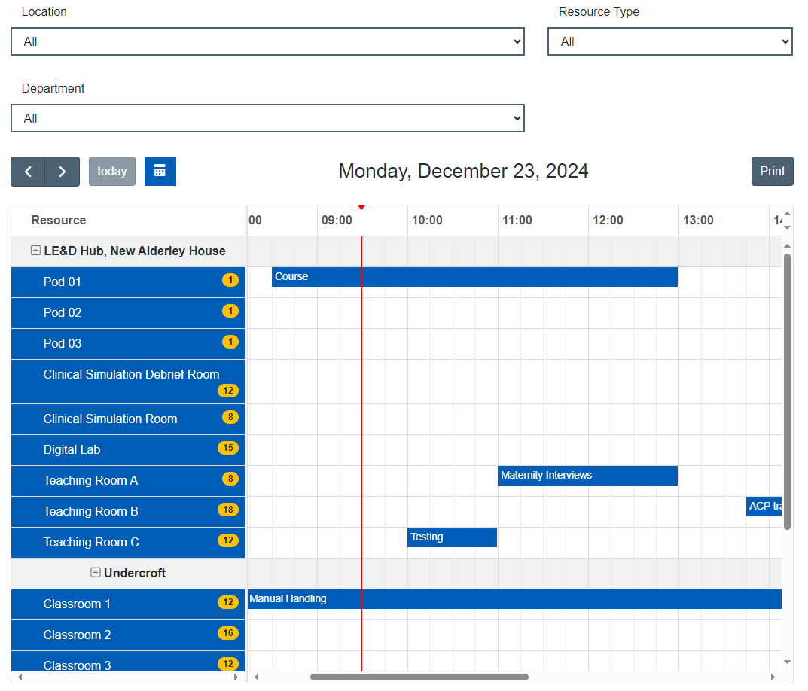
This will take you to the Bookings screen. Scroll down to view the diary for the room you selected.
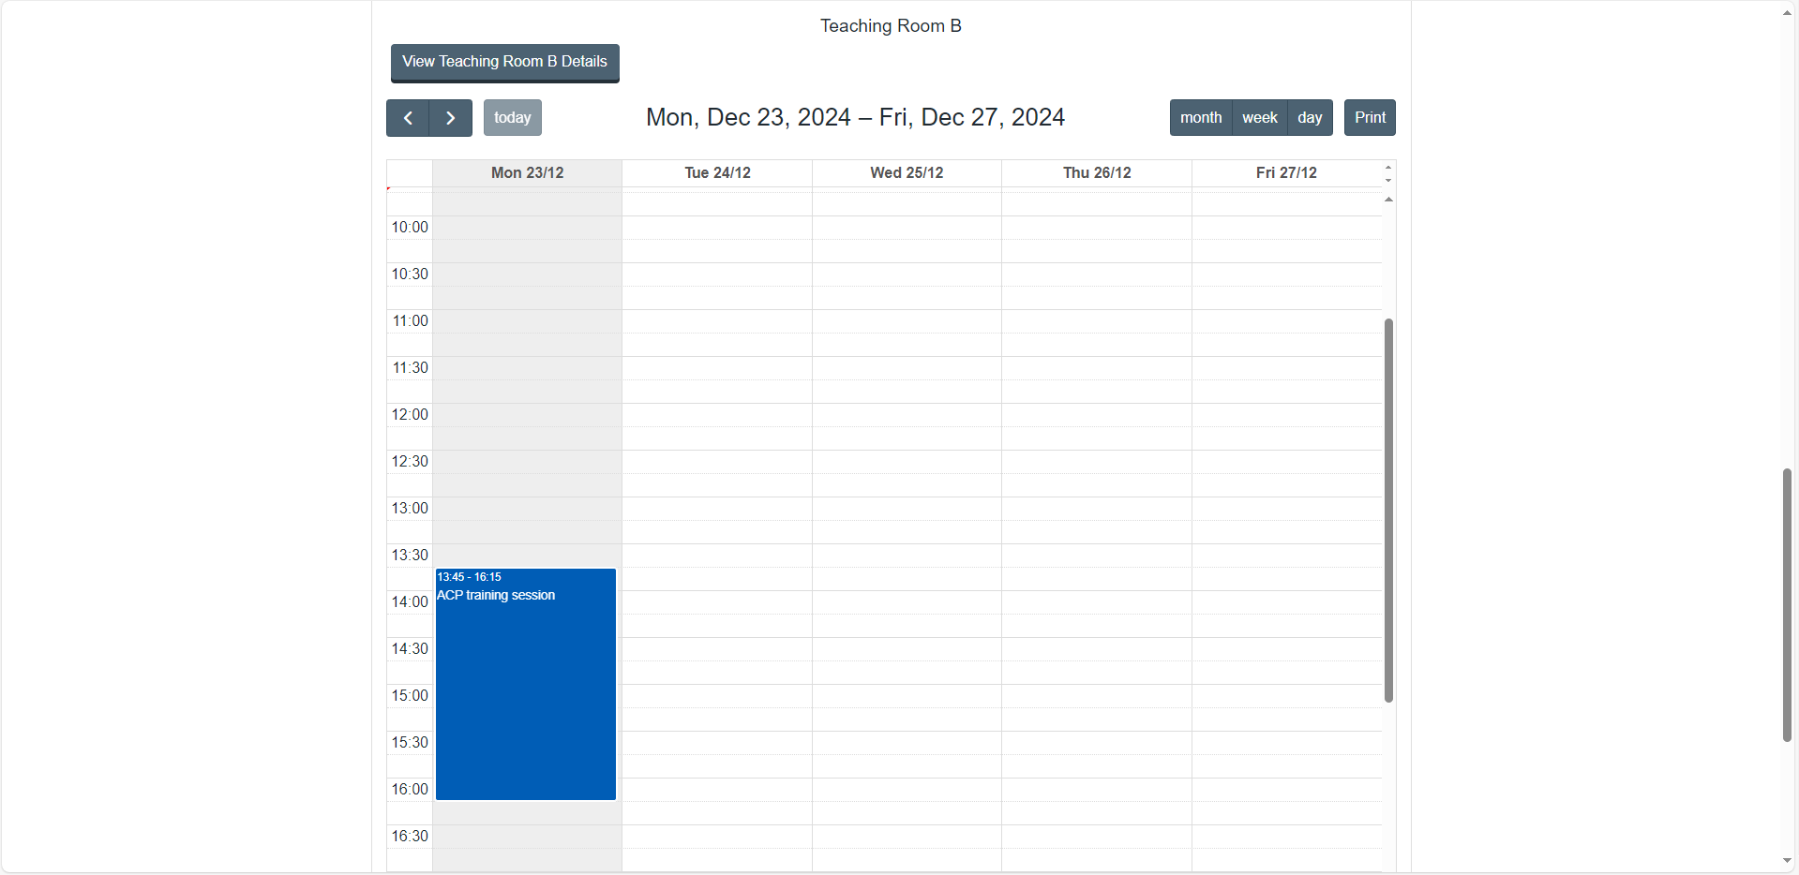
The date range will show at the top of the diary. Click in the grid at the right date and time.

This will open a form that you need to complete.
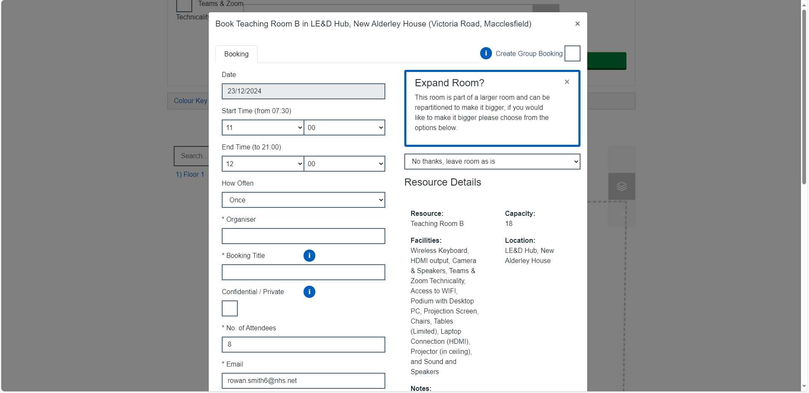
Here, you can:
- Enter the start and end time.
- Change the name of the organiser (this will default to your name).
- Give the booking a title.
- Select whether it’s confidential/private – this will hide the name of your booking from public display.
- Change the number of attendees.
- Change the email address for the confirmation to go to (this will default to your email address).
- Add an additional email for the confirmation to go to.
- Select if you want to receive an email calendar invite.
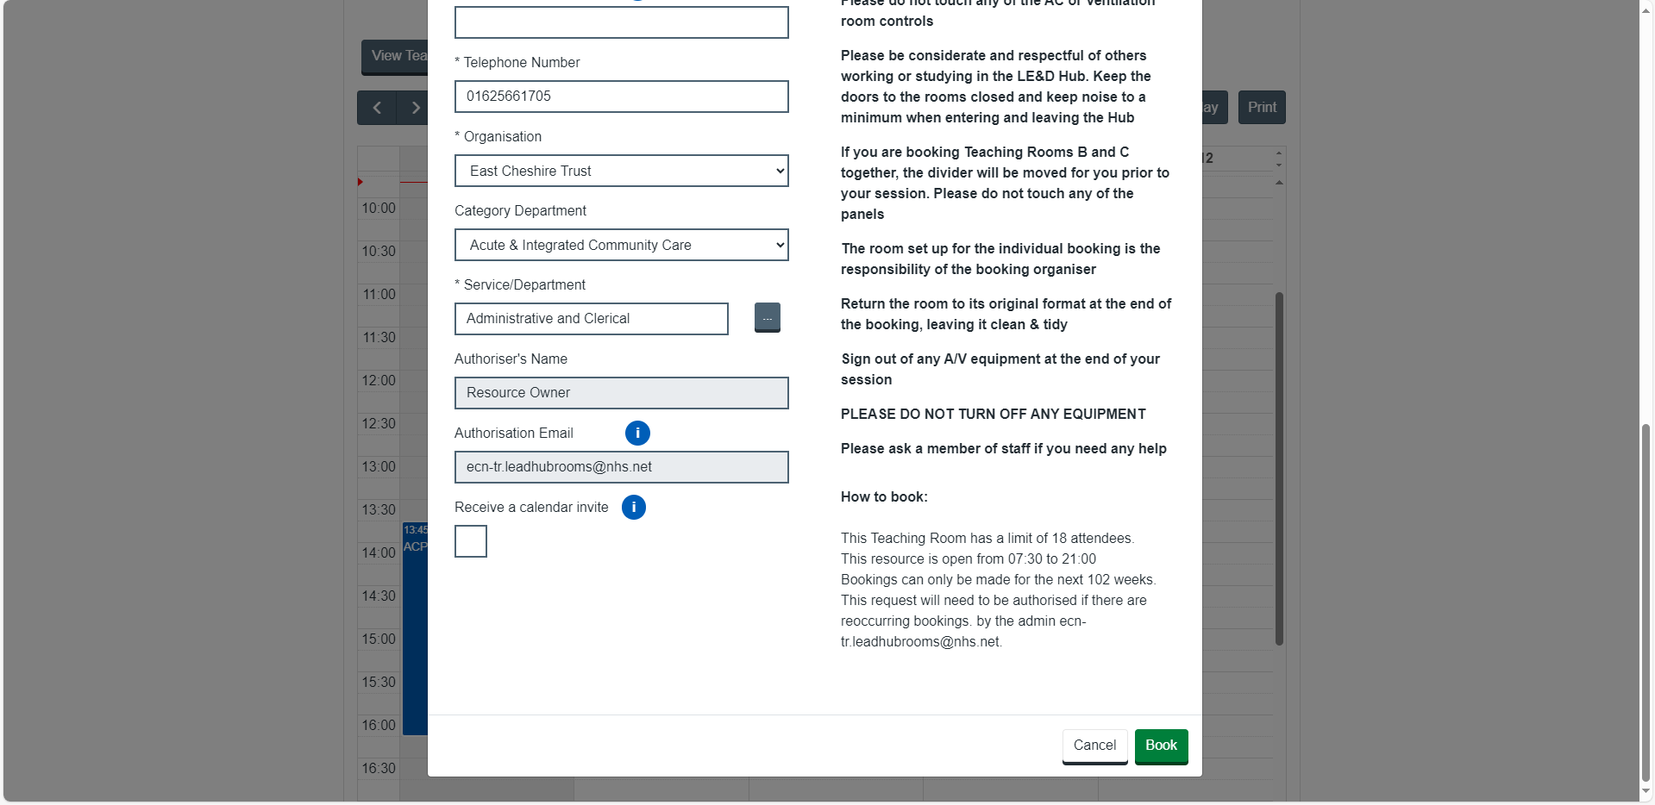
At the bottom of this form, click ‘Book’. This will send your booking request to the relevant team to approve, depending on what room you’ve requested. See the Approval and confirmation section.

If you don’t know which room you want
From the UBook homepage, fill out the Quick Search form at the top of the screen.
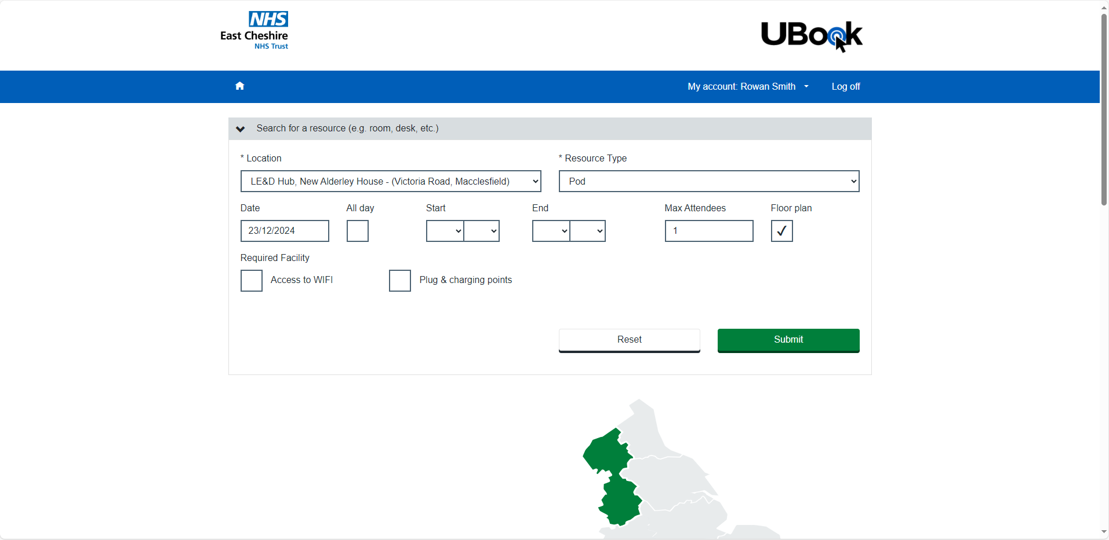
Select the location, resource type (meaning room type), date, time and attendees. Depending on the room type, more options will appear for you to select. Then click ‘Submit’.
This will take you to the Bookings Quick Search screen.
Scroll down to view a floorplan. The rooms highlighted in green are available and meet your requirements. Rooms shown in red are not available.
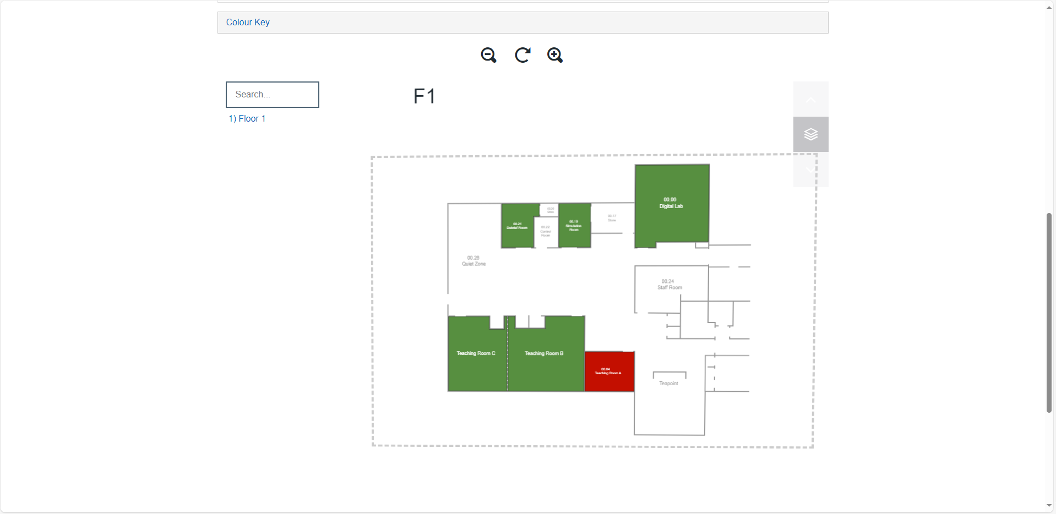
Click on a room to view more information about it. From here, click ‘Book’.
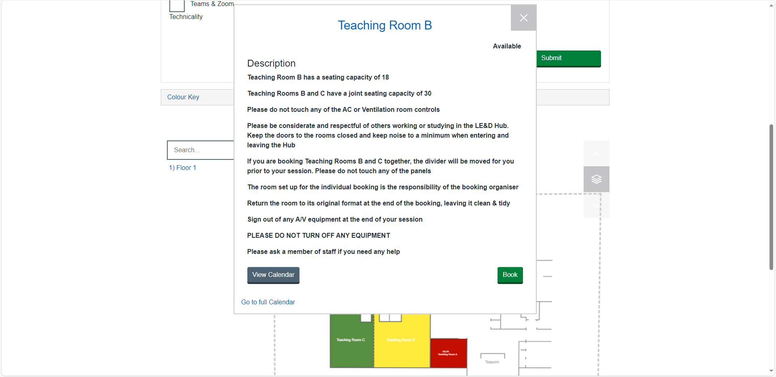
This will open the same form as before that you need to complete.
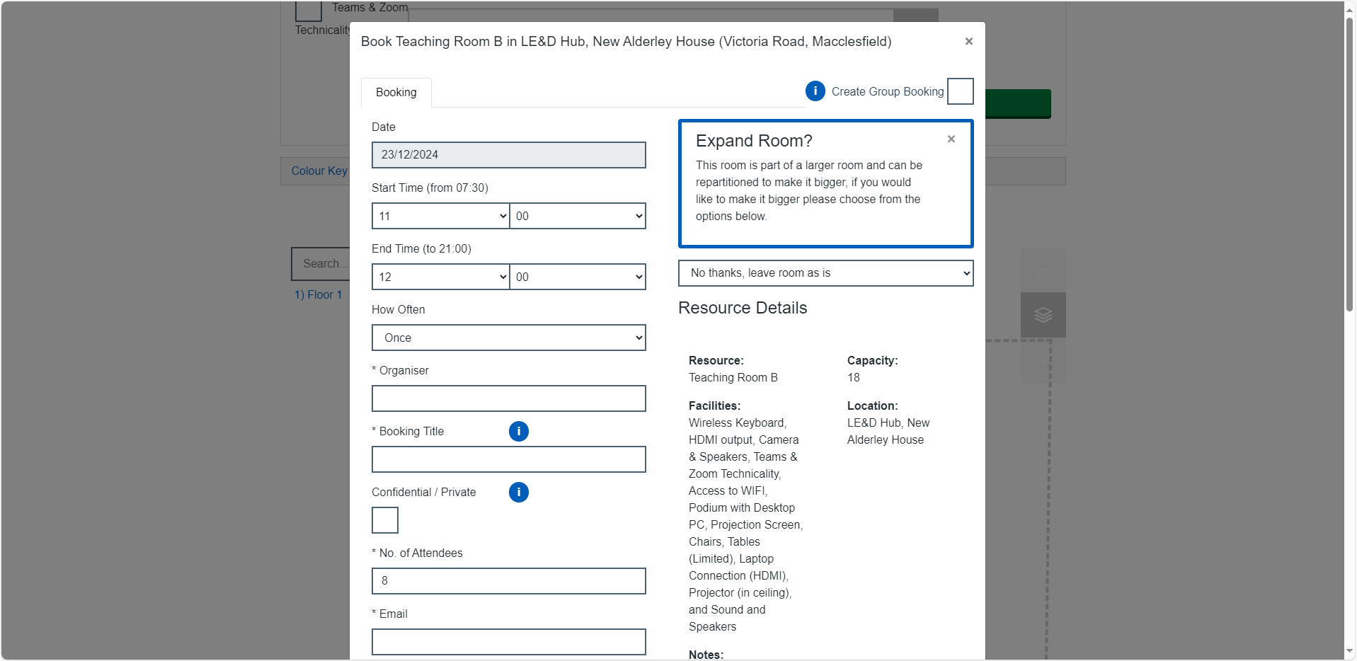
At the bottom of this form, click ‘Book’. This will send your booking request to the relevant team to approve depending on what room you selected.

Recurring bookings
To request a recurring booking, follow either booking method until you reach the screen below.
Under ‘How Often’, change the frequency to Daily, Weekly or Monthly.
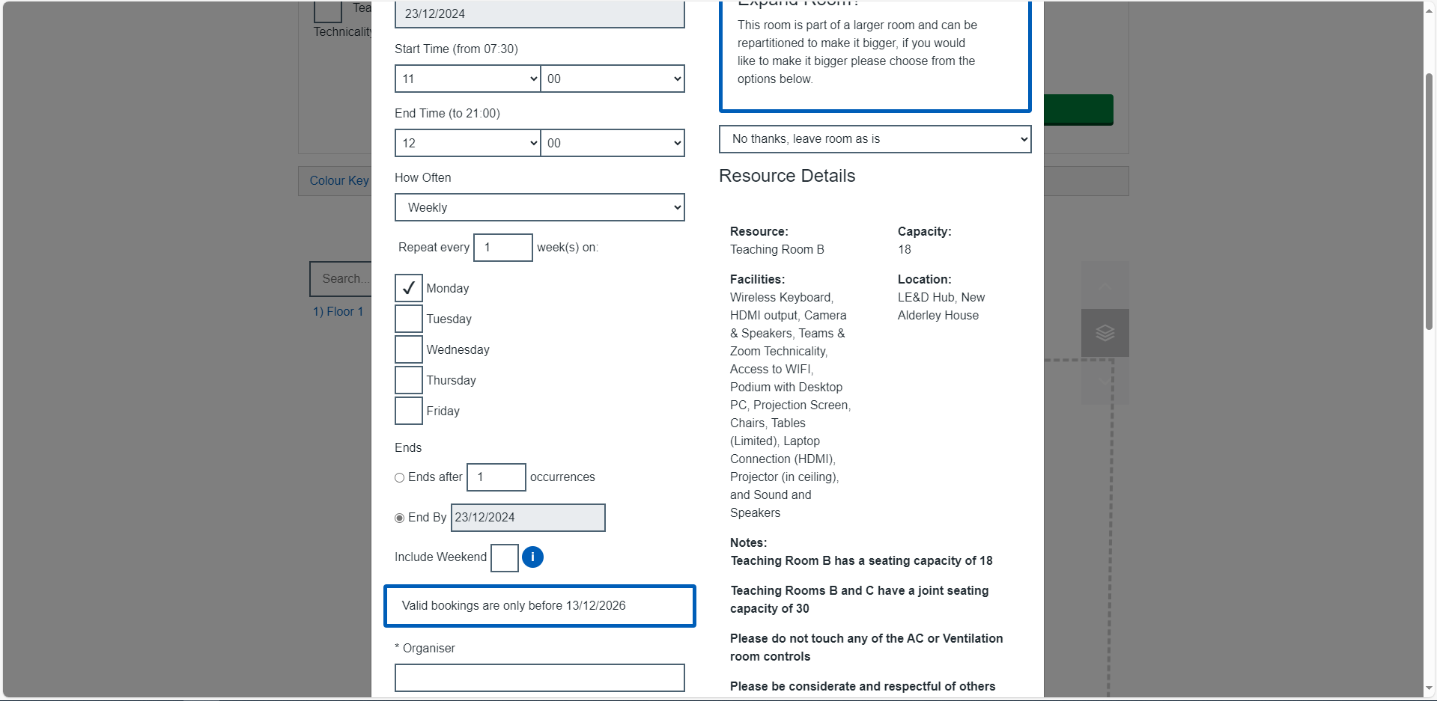
The ‘End by’ date will default to the date of the first booking. Make sure that you change this to the correct end date.
Fill out the rest of the form as you would any other booking and click ‘Submit’ to send the booking request.
Please note that even if your booking is approved, any dates that clash with existing bookings will not be booked. You can check this by clicking the link in booking request confirmation email to view or cancel the booking. This will show you a list of the bookings and the status of each, which will show what has or hasn’t been booked. See the ‘Viewing or cancelling bookings’ section for more details.

Approval and confirmation
You will receive an email confirming that your booking request has been sent. Keep this email as it contains a link to view or cancel your booking.
You’ll receive a second email once your booking has been approved or rejected. If you selected ‘Receive a calendar invite’ on the booking form, you’ll receive a calendar invite when your booking is approved.

Viewing or cancelling bookings
In the booking request confirmation email you receive when you submit a request, there is a link to view or cancel.

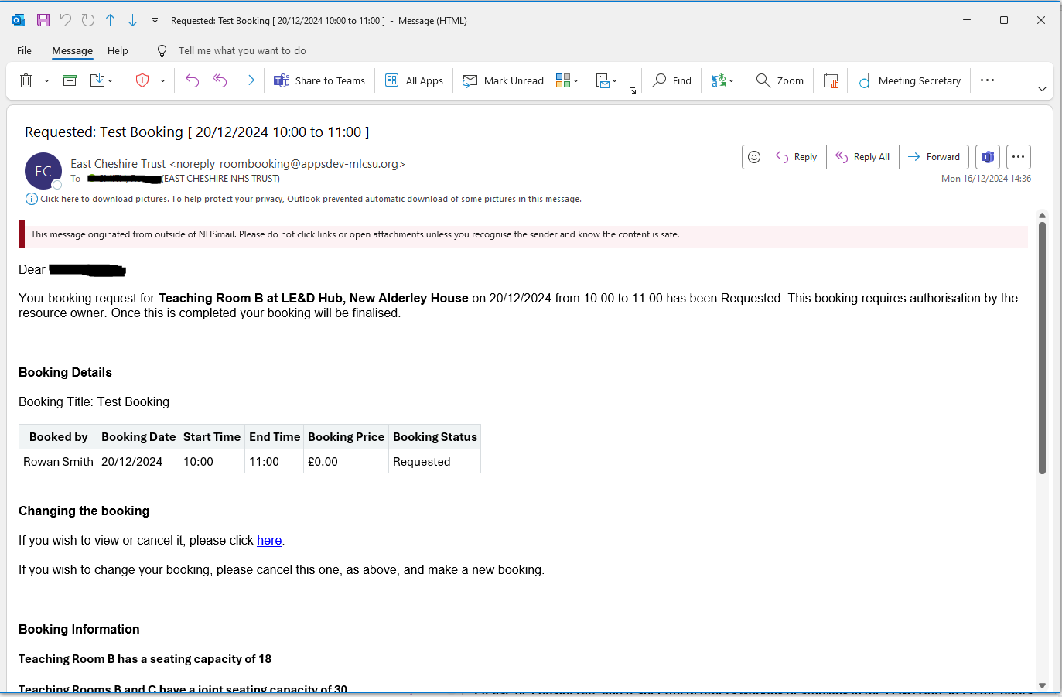
Click the link, which will take you to the Manage Booking page.
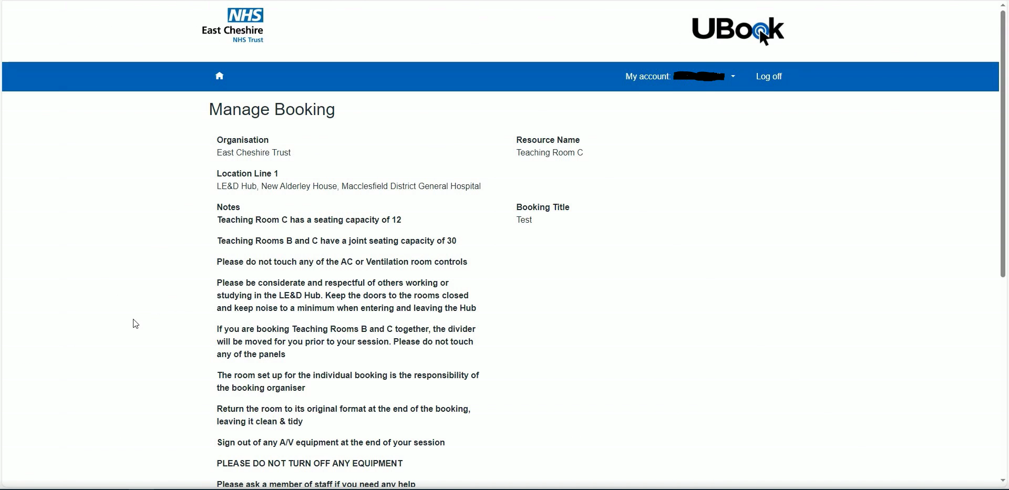
Scroll down and you will see the ‘Cancel’ and ‘Edit’ options.
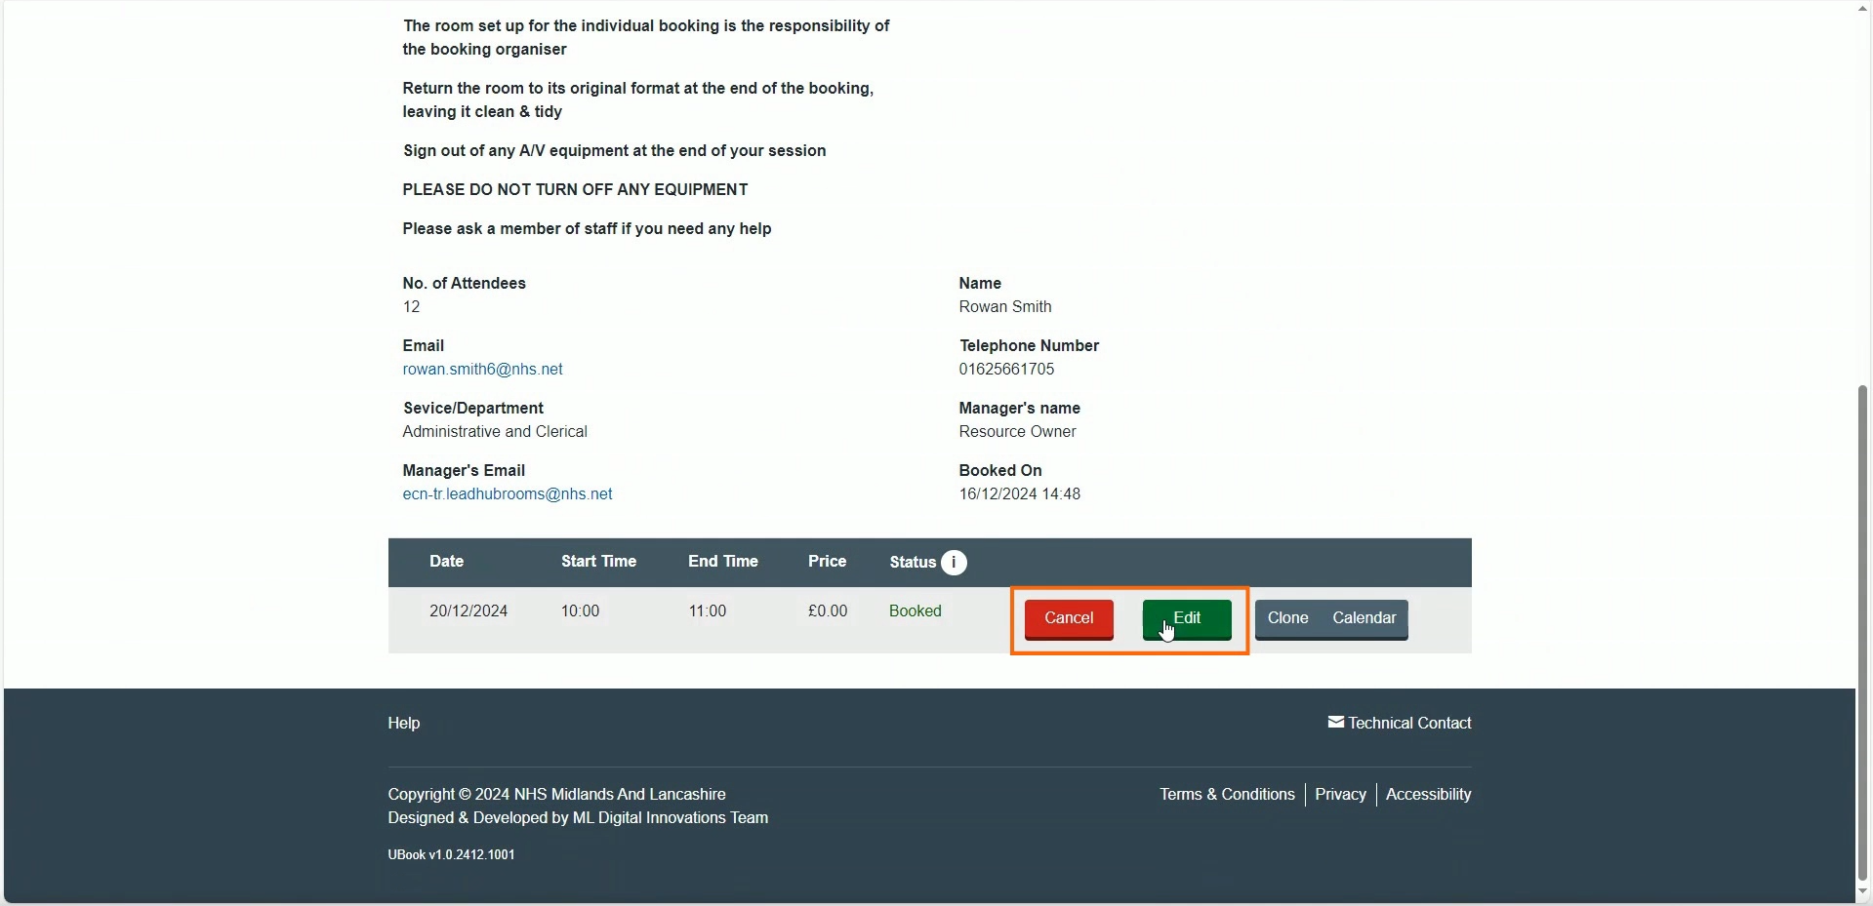
It’s better to cancel the booking and re-book rather than edit. Once you’ve cancelled the booking, the status will change to ‘Cancelled’. You’ll also receive a confirmation email.
Please note that deleting a booking in your own calendar will not cancel the booking.

Rejected bookings
Sometimes, your booking might be rejected. You’ll receive an email confirmation, which will also contain the reason under ‘Booking Details’.
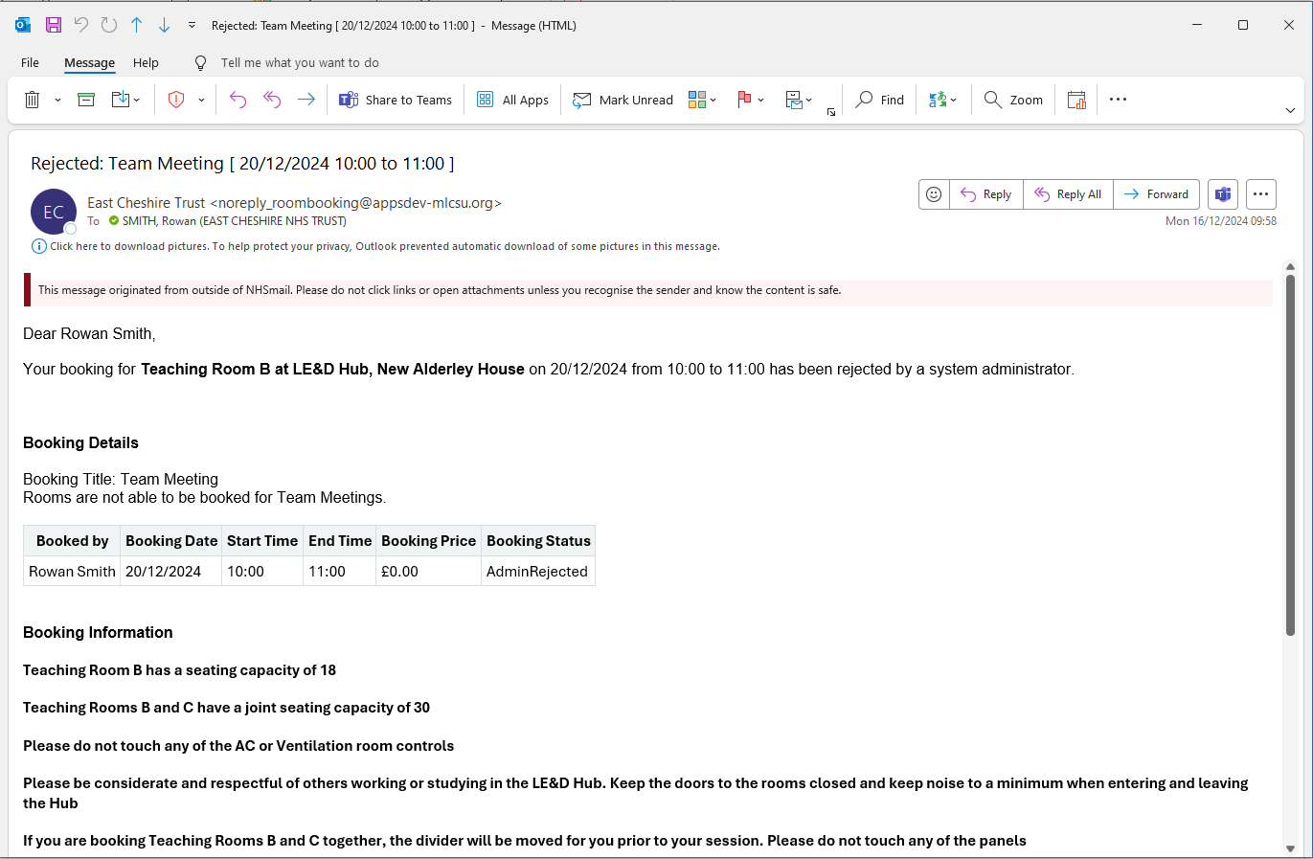
For example, if you book a meeting in one of the LE&D Hub rooms, this will be rejected unless it’s booked less than 48 hours in advance.
If you have queries about a rejected booking, contact the relevant team for the room you requested.

Contacts
LE&D Hub Rooms and Lecture Theatre: ecn-tr.leadhubrooms@nhs.net
New Alderley House Meeting Rooms and Boardroom: ecn-tr.meetingroombookings@nhs.net
Undercroft: ecn-tr.professionalpracticeteam@nhs.net

