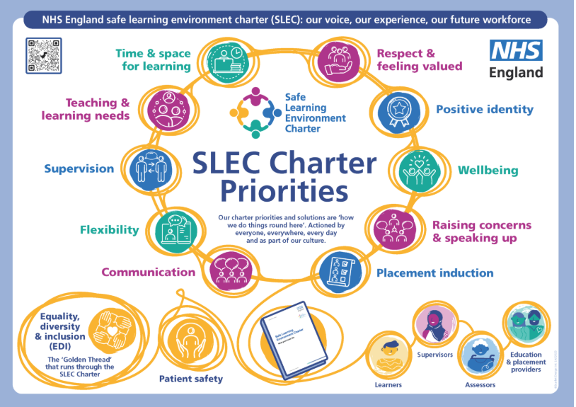

The Safe Learning Environment Charter (SLEC) was developed in response to healthcare learner feedback on clinical experiences in maternity services (Kirkup 2015, 2022 and Ockenden 2020, 2022 reports). The key themes arising from these reports were: the need for safer staffing, a well-trained workforce, teamwork, transparency, compassionate care, learning from incidents and listening to families. SLEC comprises of 10 priorities which must be implemented by all education and placement providers and applied to learners of all professions and those responsible for supporting placement learning. SLEC sets out the supportive learning environment required to allow learners to become well-rounded professionals with the right skills and knowledge to provide safe and compassionate care of the highest quality. Patient safety is at the heart of SLEC and the golden thread of Equality, Diversity and Inclusion is woven into all 10 priorities.
The SLEC has been included in PLATO to complement this learning and enhance understanding how the SLEC encourages a culture of continuous learning where everyone is actively involved in improving the learning experience'.

Click here to find out more: NHS England » Safe Learning Environment Charter – what good looks like

