Journal Club Handbook

Library & Knowledge Service  2nd Floor, New Alderley House  Macclesfield District General Hospital  Victoria Road, Macclesfield, SK10 3BL |  | 
Tel: 01625 66 1362 | Email: ecn-tr.StaffLibrary@nhs.net


Contents
1. Introduction 3
2. What is Journal Club? 3
3. How is Journal Club organised? 3
4. Guidance for the Presenter 3
4.1 Identify a knowledge gap and frame a clinical question 4
4.2 Literature search for best evidence to answer the question 7
4.3 Appraise the evidence 7
4.4 Email the paper 7
4.5 Prepare the presentation 8
4.6 Present the findings at Journal Club 13
5. Recommended reading 13
6. Glossary 14
7. Criteria for assessing Journal Club presenters 18

This handbook is an amended version of the Journal Club Handbook from Sheffield Children’s NHS FT and Birmingham Women’s NHS FT.

Revised July 2021

Introduction
Evidence-based medicine (EBM) integrates current best research evidence with clinical experience and thus aids decision-making in patient care.

What is Journal Club?
Journal Club is an opportunity for clinicians to learn the principles of evidence-based practice through posing a clinical question, literature searching and critical appraisal. Additionally, it offers the opportunity to hone presentation skills and receive feedback within an informal forum. The format of Journal Club is group, problem-based learning in which a presenter delivers a structured interactive presentation. The content of the presentation is the critical appraisal of a research paper with the option of using the CASP tool. (Critical Appraisal Skills Programme) The aim is to challenge current practice and determine whether the research evidence supports a change in practice. Appraisal is continued by the group discussion which follows and may conclude by determining whether or not current practice should be altered in light of the presenter's findings.

How is Journal Club organised?
Journal clubs at ECT are currently organised by department but if you would like some help in the administration or setting up a journal club please contact the Library on:
ecn-tr.StaffLibrary@nhs.net

Guidance for the Presenter
There are five stages to follow:
1. Identify a knowledge gap and frame a clinical question
2. Literature search to answer that question
3. Select a paper and appraise it using CASP
4. Email the paper details to club members
5. Prepare the presentation and present the findings at Journal Club

Journal Club Flowchart
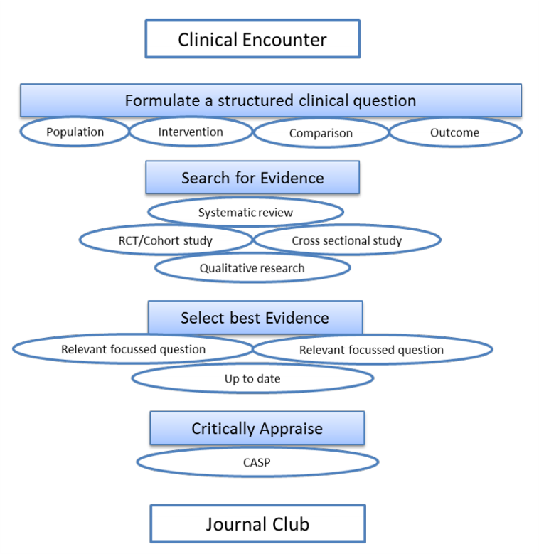

4.1 Identify a knowledge gap and frame a clinical question
The first step in EBM is to define a structured clinical question. The question should arise from clinical practice. Using the PICO acronym will help you organize your query into a searchable question. In addition to the PICO elements of your clinical question, it’s important to know:
- what TYPE of question you are asking
- what is the best STUDY DESIGN to search for in order to find evidence that answers your clinical question.

P. I. C. O. Model for Clinical Questions
P | Patient or Population | How would I describe a group of patients similar to mine
I | Intervention | Which main intervention, prognostic factor, or exposure am I considering?
C | Comparison | What is the main alternative to compare with the intervention? (if applicable)
O | Outcome | What can I hope to accomplish measure, improve or affect?
D | Type of question and  Study design | Therapy/Treatment, Diagnosis, Prognosis, Harm / Aetiology. What would be the best study design

Structured PICO question | Type of question & study design
In children with a moderate to severe asthma exacerbation (P), does Atrovent (C) added to salbutamol (I) reduce the rate of admission (O)? | Therapy  RCT
Among children with minor head injury (P) does the use of CT scan (I) versus other clinical findings (C) affect identification and diagnosis of intracranial hemorrhage (O)? | Diagnosis  Cross sectional study
In children who were born full-term with normal birth weight (P), is maternal infection (I) a possible cause of congenital cerebral palsy (O)? | Etiology/Harm  Cohort Studies
Among toddlers with recurrent nasal discharge (P) does the use of antibiotics (I) affect the probability of recurrence (O)? | Prognosis  Cohort Study  Case Control Study

Some Study Designs..... (see glossary for definitions)
Systematic Review  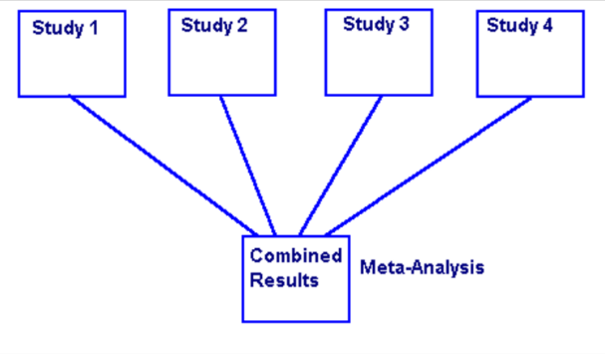 | Randomised Controlled Trial  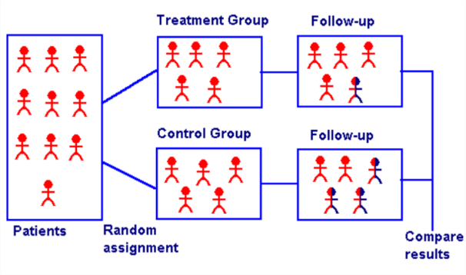
Cohort Study  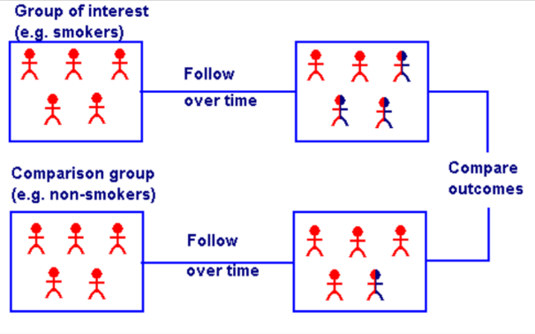 | Case Control  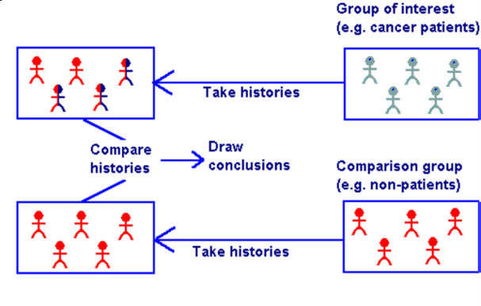
Cross Sectional Study  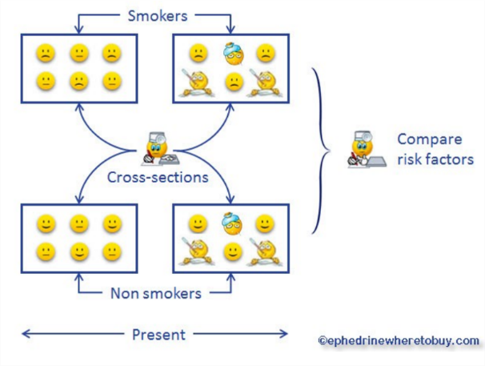 | Qualitative Research  

4.2 Literature search for best evidence to answer the question
The second stage in EBM is a literature search to identify a study that will help answer the question. When searching for evidence use terms identified in PICO and consider an appropriate research design (RCT, cohort study etc).
A literature search may include:
- Electronic databases: Medline, Embase, Cinahl, Cochrane database, NICE available from https://www.nice.org.uk/about/what-we-do/evidence-services/journals-and-databases.
- Hand search of journals.
- Grey literature: reports (government or academic), conference proceedings, internet, libraries, professional societies, Kings Fund, Nuffield.
- Research registers: National Research Register, HTA database, Cochrane.
- Retrieved articles: bibliographies, search authors names, citation threads.
- Contact with researchers or “experts” Ideally, evidence-based clinical practice guidelines relevant to your question will already exist. When this is not the case you need to seek out the best scientific evidence available to help inform the treatment decision.

4.3 Appraise the evidence
The next stage is to critically appraise the selected study. This can be made easier by using an appraisal tool. CASP - a tool that can be used for all types of question is the Critical Appraisal Skills Programme available at https://casp-uk.net/casp-tools-checklists/.



4.4 Email the paper
At least one week before presentation send the chosen paper to journal club members.

4.5 Prepare the presentation
The PowerPoint presentation should last no more than 30 minutes to allow time for discussion. The following slides are an example of what should be included.

 | Greet the audience,  introduce yourself and  the topic of the  presentation
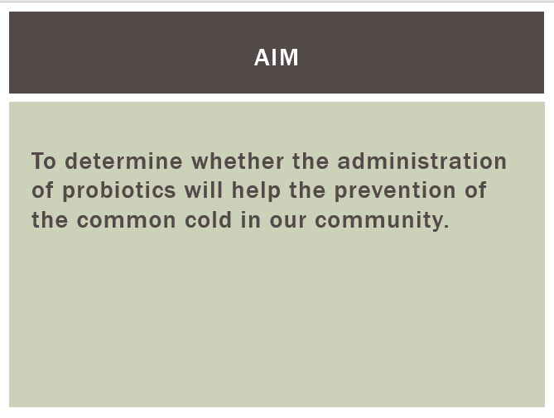 | The aim is what you  want to achieve e.g. to  determine if one therapy  is better than another.
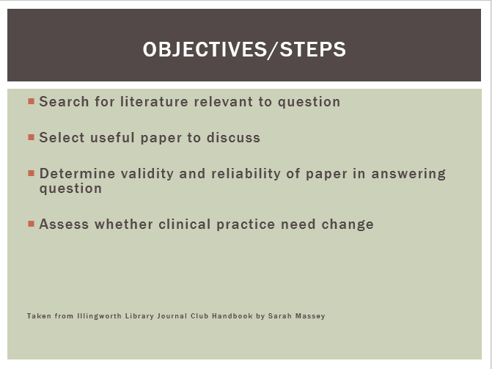 | The objectives are how  to achieve the aim.  There is typically one  aim and two or three  objectives.
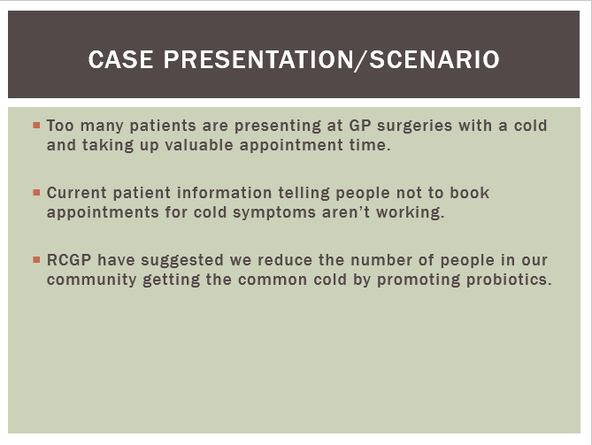 | Provide a brief case  presentation, which  typically identifies the  case that gives rise to  the question being  presented or why this  question/topic is of  particular interest.
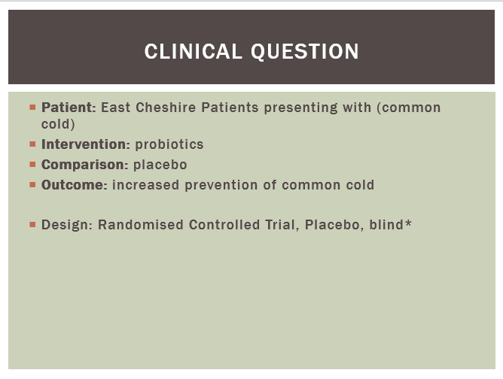 | Provide a clear and  concise clinical question  and identify the PICO  facets.
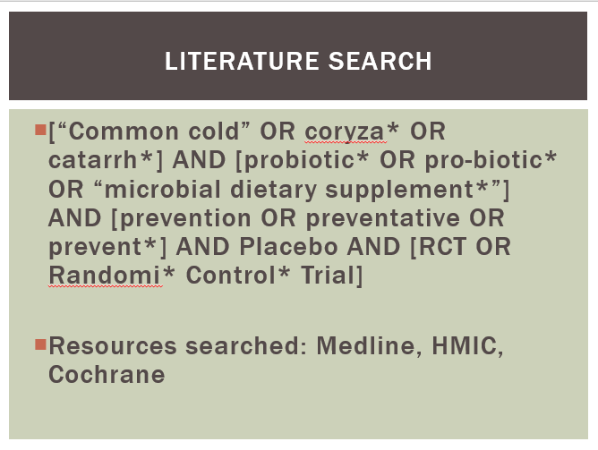 | Provide details of the  key terms used in the  literature search and  identify the resources  used e.g. Medline.  Provide details of the  results of the search e.g.  4 RCTs were found in  Medline.
 | Provide bibliographic  details of the paper  selected and state why  this paper was chosen  e.g. the most relevant  paper, up to date,  adequate participant  numbers, good  methodology etc.
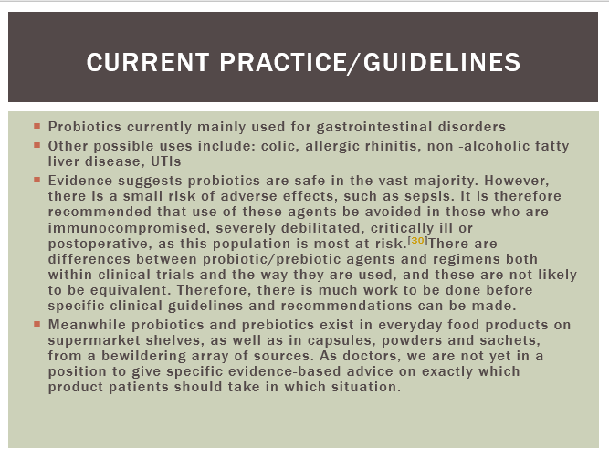 | Provide details of NICE  and ECT guidelines  (where available)  Identify issues of  concern e.g. guidelines  unclear, outdated  and/or unspecific to  answer question being  presented.
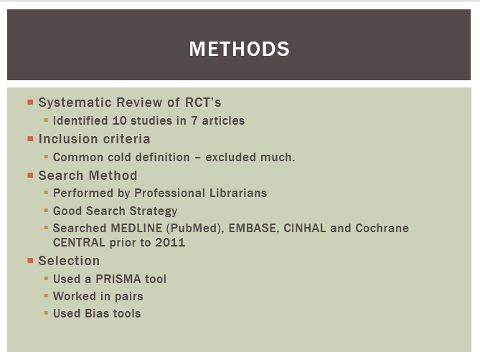 | Describe the study to  the audience to help get  a feel of the content and  understanding of the  methods used.
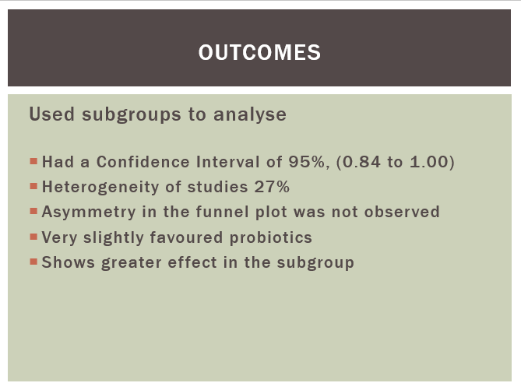 | Copy and paste useful  charts or tables from the  study paper, and explain  their significance to the  audience.  This might need more  than one slide.
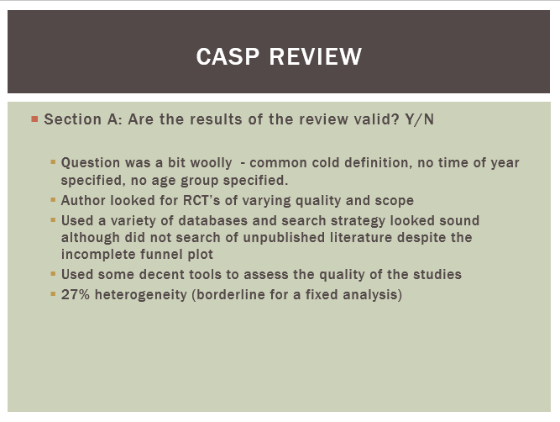 | Look at CASP checklists and talk about the reasons for your answer to each question.
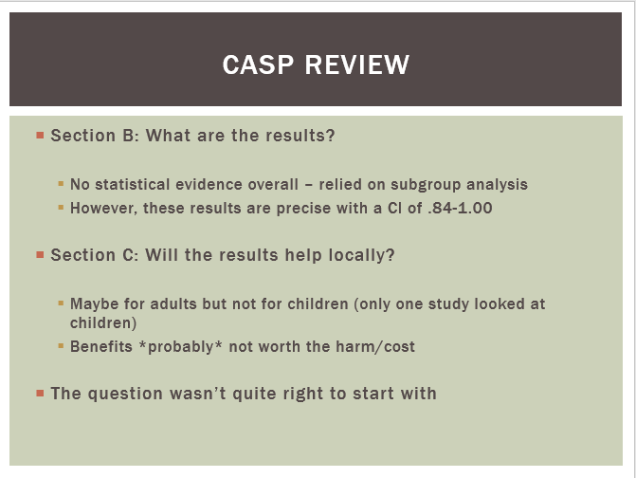 | Add the reasons for your  decision on the slide or  in the notes field of the  presentation.  Add extra notes after  the discussion so those  who did not attend can  gain the benefit from  the discussion.
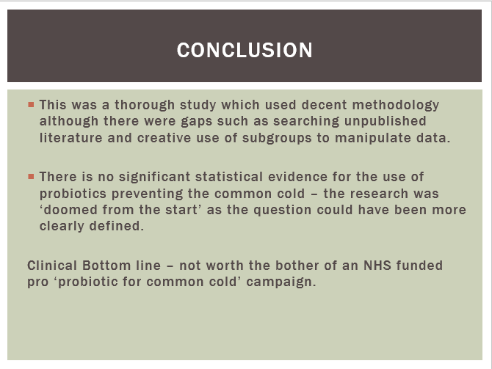 | Summarise the findings  and provide a  conclusion, stating how  well the aims and  objectives were  achieved.  The findings may prompt  change of policy at ECT.  Thank the audience and  take questions


4.6 Present the findings at Journal Club

4.6.1. The role of the presenter:
- Choose the clinical question either from an area of interest.
- Ensure the paper is circulated to members at least a week before Journal Club.
- Arrive in time to set up the presentation to enable a timely start
- Keep to time - presentation to be no longer than 30 minutes
- Arrange feedback if wanted.
- Hopefully the papers chosen will spark discussion and possibly controversy. The aim is not to select “the perfect paper” but about appraising what evidence is available – even if it is fundamentally flawed.

4.6.2. The role of non-presenting members:
- To arrive promptly
- To have read the paper beforehand
- To participate in discussion
- To take their turn presenting

4.6.3. The role of the clinical librarian (if required)
- The librarian is available to help with the literature search and selection of a paper.
- The library staff can help with the organisation if required.
- Will complete feedback on the presentation if requested.
- Can upload the presentation to a ‘journal club repository’ on the library website.

Recommended reading
These are in stock in the Library. Check the catalogue: http://maccle.cirqahosting.com
- Bootland, D. (2017) Critical appraisal from papers to patient. CRC Press.
- Gosall N.K. and Gosal, G.S. ( 2015). The doctor's guide to critical appraisal. 4tg ed. PasTest .
- Greenhalgh T. (2019 ). How to read a paper : the basics of evidence-based medicine. Wiley-Blackwell.
- Moule,P. (2018) Making sense of research in nursing, health and social care. 6th ed. Sage.

See also the website of the Centre for Evidence Based Medicine: http://www.cebm.net

Glossary
Absolute risk: measures the probability of an event or outcome occurring (e.g. an adverse reaction to the drug being tested) in the group under study.
Absolute risk reduction (ARR): the ARR is the difference in the risk of an event occurring between two groups, for example, if 6% of patients die after receiving a new experimental drug and 10% of patients die after having the existing drug treatment then the ARR is 10% - 6% = 4%. Therefore, by using the new drug 4% of patients can be prevented from dying.
Allocation concealment: to be effective, the process for randomisation must ensure that no one involved in the study can influence the group each patient is allocated to. Allocation concealment is best achieved by using a centralised computer allocation process.
Bias: influences on a study that can lead to invalid conclusions about a treatment, which can make that treatment appear better or worse than it is. Bias can occur by chance or as a result of a systematic error on the design and execution of a study. It can occur at different stages in the research process, for example, in the collection, analysis, interpretation or publication of research data.
Blinding: the practice of keeping the subjects and / or the investigators of a study ignorant of the group to which a subject has been assigned. For example, a trial in which both the patients and doctors are unaware of whether the patients are taking the experimental or control drugs. The purpose of blinding is to protect against bias. See also double blind, single blind and triple blind study.
Case control study: a study that starts with the identification of a group of individuals sharing the same characteristics (e.g. people with a particular disease) and a suitable comparison / control group) (e.g. people without the disease). All subjects are then assessed with respect to things that happened in the past that might be related to contracting the disease under. These studies are also called retrospective as they look back in time from the outcome to the possible causes.
Cohort study: an observational study that takes a group (cohort) of patients and follows their progress over time in order to measure outcomes such as disease or mortality rates, and make comparisons according to the treatments that patients received. Cohorts can be assembled in the present and followed into the future (a concurrent or prospective cohort study) or identified from past records and followed forward from that time up to the present.
Confidence interval: a way of expressing certainty about the findings from a study using statistical measures. A confidence interval describes the range within which the true value of a measurement (e.g. effect of a treatment) is expected to lie within a given degree of certainty. It is usual to interpret a 95% confidence interval as the range of effects within which we are 95% confident that the true effect lies.
Confounding factor: a factor that influences a study that can contribute to misleading findings. For example: two groups of people, one exercising regularly the other not (the groups have a significant age difference but this is not reported), in relation to cardiovascular events the outcomes are influenced as much by age as exercising. Age is therefore the confounding factor.
Control group: a group of patients recruited to a study that receives no treatment, a treatment of known effect or a placebo - in order to provide a comparison for a group receiving an experimental treatment, such as a new drug.
Controlled clinical trial (CCT): a study testing a specific drug or other treatment involving two or more groups of patients with the same disease. One (the experimental group) receives the treatment that is being tested and the other (the comparison or control group) receives an alternative treatment, a placebo or no treatment. The two groups are followed to compare differences in outcomes to determine the effectiveness of the experimental treatment.
Cross sectional study: the observation of a defined set of people at a single point in time - a snapshot. This type of study contrasts with a longitudinal study which follows subjects over a period of time.
Double blind study: a study in which both the subject (patient) and the observer (investigator/clinician) is unaware of which treatment or intervention the patient is receiving. The purpose of this blinding is to protect against bias.
Event rate: the proportion of patients in a group where a specified health event or outcome is observed. For example, if in 100 patients the event is observed in 23, then event rate is 0.23. Control event rate (CER) and experimental event rate (EER) are the terms used in control and experimental groups of patients.
Heterogeneity: when the results or estimates of effects of treatment from separate studies appear to be different.
Homogeneity: when the results from separate studies are similar.
Information bias: pertinent to all types of study and can be caused by poorly designed questionnaires, observer or interviewer bias, response and measurement error. Intention to treat analysis: an analysis of a clinical trial where patients are analysed according to the group to which they were initially randomly allocated, regardless of whether or not they had dropped out, fully complied with the treatment or crossed over and received the alternative treatment. Intention to treat analysis are favoured in assessments of clinical effectiveness as they mirror the non-compliance and treatment changes that are likely to occur when the treatment is used in practice.
Meta analysis: results from a collection of independent studies (investigating the same treatment) are pooled using statistical techniques to synthesise their findings into a single estimate of treatment effect.
Number needed to treat (NNT): this measures the impact of a treatment or intervention. It states how many patients need to be treated in order to prevent an event which would otherwise occur. For example, if the NNT = 3 then three patients would have to be treated to prevent one adverse outcome. The closer the NNT is to 1, the better the treatment is. The number needed to harm (NNH) is the number of patients that would need to receive a treatment to cause one additional adverse event, for example, if the NNH = 4 then four patients would have to be treated for one bad outcome to occur.
Observational study: a research method that involves watching, listening and recording behaviours and actions.
Odds ratio (OR): odds are a way of representing probability that provides an estimate (usually with a confidence interval) for the effect of a treatment. Odds are used to convey the idea of risk and an odds ratio of 1 between two treatment groups implies that the risk of an adverse outcome is the same in each group.
P value: the P value is a measure of probability that a difference between groups happened by chance. It has a value ranging from zero to one. For example, P= 0.01 means that if there is a 1 in 100 chance that the result occurred by chance. The lower the P value, the more likely it is that the difference between groups was caused by treatment. P values tell us whether an effect can be regarded as statistically significant or not, it does not relate to how large the effect might be, for which we need the confidence interval. A P value of <0.05 indicates that a result is likely to be real (rather than happened by chance).
Performance bias: the systematic difference in care provided (apart for the intervention). For example carers treating patients differently according to which group they are in.
Prospective study: a study in which subjects are entered into research and then followed up over a period of time with future events recorded as they happen.
Publication bias: studies with statistically significant (or positive) results are more likely to be published than those with non significant (or negative) results.
Qualitative research: research used to explore and understand people's beliefs, experiences, attitudes, behaviour and interactions.
Quantitative research: research that generates numerical data. Randomisation: a method that uses the play of chance to assign subjects to groups in a research study, for example, by using a random numbers table or a computer generated random sequence.
Randomised controlled trial (RCT): a study to test a specific drug or other treatment in which subjects are randomly assigned to two or more groups: one (the experimental group) receiving the treatment that is being tested and the other (the comparison or control group) receiving an alternative treatment, a placebo or no treatment. The two groups are followed to compare differences in outcomes to determine the effectiveness of the experimental treatment.
Relative risk (RR): a summary measure that represents the ratio of the risk of a given event or outcome (e.g. an adverse reaction to the drug being tested) in one group of subjects compared with another. When the risk of events is the same in the two groups the relative risk is one. In a study comparing two treatments, a relative risk of two would indicate that patients receiving one of the treatments had twice the risk of an adverse outcome than those receiving the other treatment.
Relative risk reduction (RRR): tells us the reduction in the rate of the event in the treatment group relative to the rate in the control group. RRR is probably the most commonly reported measure of treatment effects.
Retrospective study: a study that deals with the present / past and does not involve studying future events.
Risk ratio: ratio of the risk of an undesirable event or outcome occurring in a group of patients receiving experimental treatment compared with a comparison (control) group.
Selection bias: selection bias occurs if the characteristics of the sample group differ from those of the wider population or when there are systematic differences between comparison groups of patients in a study in terms of prognosis or responsiveness to treatment.
Sensitivity: in diagnostic testing sensitivity refers to the chance of having a positive test result given that you have the disease. 100% sensitivity means that all those with the disease will test positive, but this is not the same the other way around. A patient could have a positive test result but not have the disease - this is called a false positive. The sensitivity of a test is also related to its negative predictive value (true negatives) - a test with a sensitivity of 100% means that all those who get a negative test result will not have the disease.
Single blind study: a study in which either the subject or the observer is not aware of which treatment or intervention the subject is receiving.
Specificity: in diagnostic testing specificity refers to the chance of having a negative test result given that you do not have the disease. 100% specificity means that all those without the disease will test negative, but this is not the same the other way around. A patient could have a negative test result but still have the disease - this is called a false negative. The specificity of a test is also related to its positive predictive value (true positives) - a test with a specificity of 100% means that all those having a positive test result definitely have the disease.
Systematic review: a review in which evidence from studies has been identified, appraised and synthesised in a methodical way according to a predetermined criteria.

Criteria for assessing Journal Club presenters

Name of presenter

Date of presentation

Name of Chair

Question/topic

Study selected

Were the following slides included in the presentation?
- A clear question
- Aims and objectives
- A case report/context of the question
- Literature search (databases / PICO / search terms)
- Details of any Guidelines relating to the study
- Bibliographic details of the paper selected
- A flow chart of the study / details of the study
- Appraisal of the study using CASP
- A summary / conclusion

Quality of the presentation
Please tick | excellent | good | adequate | bad
Clear communication
Good use of media
Interactive
A positive response to comment/criticism

Did the presenter put enough time and effort into the presentation?
Please tick
Good time & effort |  | Just enough |  | More of both needed

Did the presenter demonstrate good knowledge of the topic presented?
Good knowledge |  | Poor knowledge

