Windows Keyboard Shortcuts

Windows 10 includes a wide range of keyboard shortcuts to help users navigate the operating system, perform tasks more efficiently, and access various features quickly.
Here's a list of some commonly used keyboard shortcuts in Windows 10.
The 1st key listed, you'll need to press and hold. The 2nd key, you'll need to tap once, while still holding the 1st key. If there are 3 keys listed, press and hold the first 2 in the order that they're written, and tap the 3rd key.
Win = Windows key
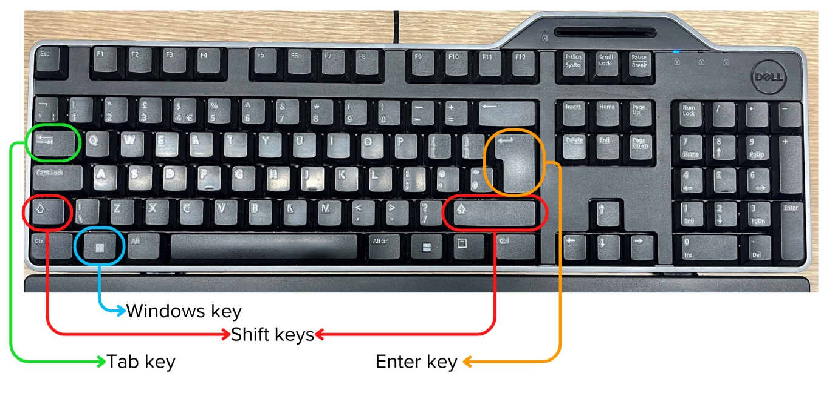
General Shortcuts:
Win + D: Show desktop (minimize or restore all open windows)
Win + E: Open File Explorer
Win + L: Lock the computer and switch user
Alt + Tab: Switch between open windows and applications
Ctrl + Shift + Esc: Open Task Manager
Ctrl + Alt + Delete: Open security options (such as Lock, Switch User, Sign out, Task Manager)
Win + Pause/Break: Open System Properties

Text Editing and Navigation Shortcuts:
Ctrl + C: Copy selected text or item
Ctrl + X: Cut selected text or item
Ctrl + V: Paste copied or cut text or item
Ctrl + Z: Undo the last action
Ctrl + Y: Redo the last undone action
Ctrl + A: Select all text or items in a document or folder

Screen Capture and Snipping Tool Shortcuts:
Win + Shift + S: Capture a selected area of the screen (opens Snip & Sketch)
Win + PrtScn: Capture the entire screen and save it to the Screenshots folder
Alt + PrtScn: Capture the active window and save it to the clipboard

Accessibility Shortcuts:
Win + Ctrl + C: Toggle colour filters on or off
Win + Ctrl + N: Open Narrator settings
Win + Ctrl + Enter: Activate Narrator
Win + Plus (+)/Minus (-): Zoom in or out using Magnifier

